**DriverPass Business Requirements Document**

Tariq Mack

CS-320 Software Test QA

June 6, 2025

# System Components and Design

Purpose

• The purpose of this project is to develop an online practice exam and on-the-road training system for DriverPass.   
• DriverPass aims to improve pass rates for student drivers by providing realistic practice exams and scheduling tools for on-the-road driving lessons.  
• The client wants a user-friendly system that can manage user accounts, track progress, and provide administrative insights for instructors and management.

System Background

• DriverPass has identified that many students fail their driving test because they rely solely on outdated materials.  
• The system is intended to solve this by offering up-to-date practice exams and direct access to book real-world driving lessons.  
• Key components include user authentication, practice exam delivery, appointment scheduling, data tracking, and reporting dashboards.

Objectives and Goals

• Provide secure login and registration for students, instructors, and management.  
• Deliver high-quality practice exams that reflect real exam conditions and content.  
• Enable students to schedule on-the-road lessons with qualified instructors.  
• Allow instructors to manage their schedules and track student progress.  
• Provide management with insights into system usage and student performance data.  
• Aim to increase driving test pass rates by 25% within six months of launch.

# Requirements

Nonfunctional Requirements

Performance Requirements

• The system must operate on web browsers and mobile devices with responsive design.  
• It should support at least 500 concurrent users without lag.  
• Updates will be scheduled quarterly for content and performance improvements.

Platform Constraints

• The system will run in a cloud-hosted environment to ensure scalability.  
• Compatible with Windows, Mac, and mobile platforms.  
• A secure database will store user accounts, exam data, and appointment schedules.

Accuracy and Precision

• Each user will be identified by unique IDs and secure login credentials.  
• User input will not be case-sensitive to reduce user errors.  
• Admins will be alerted to suspicious login activity or data errors automatically.

Adaptability

• The system will use modular design to allow updates without code rewrites.  
• It will support adding/removing/modifying users through an admin interface.  
• IT administrators will have elevated permissions to manage content and settings.

Security

• User login will require strong passwords with encryption (HTTPS).  
• The system will lock accounts after multiple failed login attempts to prevent brute force attacks.  
• Password reset functionality will be secure, using verification emails and recovery questions.

Functional Requirements

• The system shall allow students to register and manage their accounts.  
• The system shall provide access to practice exams for students.  
• The system shall allow students to schedule on-the-road lessons with instructors.  
• The system shall allow instructors to view and manage their availability and appointments.  
• The system shall track and store exam results and appointment data.  
• The system shall provide managers with access to reports on system usage and student progress.  
• The system shall support updates to exam content by administrators.  
• The system shall include multi-language support for diverse users.

User Interface

• The interface will support three roles: students, instructors, and managers.  
• Students will interact with the system via mobile devices and web browsers for exams and scheduling.  
• Instructors will access the interface to manage lesson schedules and update student progress.  
• Managers will access performance and progress dashboards through a web interface.  
• The interface will use intuitive design, color contrast, and accessible fonts to meet accessibility standards.

Assumptions

• It is assumed that all users will have internet access and basic computer literacy.  
• It is assumed that instructors and managers will complete training to use the system effectively.  
• It is assumed that email addresses provided by users are valid and regularly monitored.

Limitations

• The system will not integrate directly with state driving test booking systems in phase one.  
• Payment processing will not be included in the initial phase.  
• Offline access will not be supported in the first release for security and data consistency reasons.  
• Budget and timeline constraints may limit feature expansion in phase one.

Gantt Chart

Below is the Gantt chart screenshot showing the project schedule:

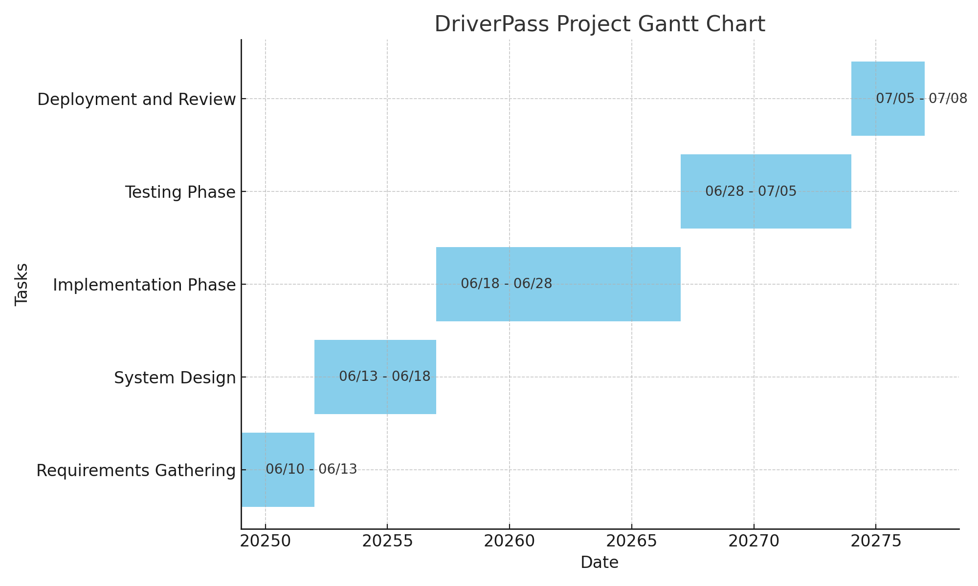

The Gantt chart reflects the phased approach of requirements gathering, design, implementation, testing, and deployment. Dependencies and timelines have been prioritized based on the DriverPass team's feedback.